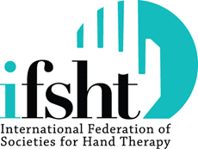 | Commercial Sponsors  April 2021

IFSHT's Mission is “to provide global networking and educational opportunities to develop and enhance the practice of hand therapy”. IFSHT draws together 52 countries around the world providing grants for teaching and learning, supporting emerging countires, co-hosting a triennial congress and providing online support and development in hand therapy.
Commercial Sponsorship
Commercial organisations are invited to support the activities of IFSHT. IFSHT sponsorship gives you unique access to potential new markets worldwide and bring attention to your products to over 10,000+ globally mobile therapists. Commercial organisations are defined as those who market equipment, supplies, services and virtual products which are available internationally. There is an alternative scheme for educational organisations.
Sponsorship will support:
- Grants to enable therapists to attend the Triennial Congress, especially applicants from lower GDP countries
- Subsidies for corresponding/associate membership fees in circumstances of hardship
- Production of our educational quarterly newsletter

DIAMOND SPONSORSHIP
$5,000 per annum (limited to one sponsor)

- Travel award in your company name to sponsor a therapist to attend the Triennial Conference*.
- Photo opportunities with the recipient of your award
- Invitation to Speaker’s Lunch with opportunity to highlight your company by chair-drop of products
- High profile on website on the home page and congress page (full strip banner on both pages)
- IFSHT free-standing banner at Congress with your logo
- Ability to promote your sponsorship of IFSHT on your website
- Period of sponsorship = present day to June 2022
- Equivalent of $5,000 payable per annum

*The selection of the successful candidate for this Diamond sponsorship award will be done by the executive committee of IFSHT from the many applications received for the Triennial Travel Award. The process includes weighting applicants for (a) their intended participation in the congress (with higher weight given to those who intend to present) and (b) GDP of their home country (with higher weight given to low GDP countries).

GOLD SPONSORSHIP $3,000 per annum  - Full page advert in quarterly newsletter, REACH  - Logo, Company name and company description on home page IFSHT website (full strip across screen)  - Logo, Company name and company description on IFSHT Triennial Congress pages of website  - Logo, Company name and company description on Awards and Grants page of website  Period of sponsorship = present day to June 2022 | SILVER SPONSORSHIP $2,000 per annum  - Half page advert in quarterly newsletter, REACH  - Logo on home page IFSHT website (shared strip across screen with other Silver sponsors)  - Logo on Awards and Grants page of website  - Logo on Membership page of website  Period of sponsorship = present day to June 2022 | BRONZE SPONSORSHIP $1,000 per annum  - Quarter page advert in quarterly newsletter, REACH  - Logo listed on the Awards and Grants page of website.  Period of sponsorship = present day to June 2022
All the above listings on the IFSHT website will be for the duration of the sponsorship.

Further opportunity $1500
IFSHT hosts a one-day Silent Auction during the Triennial Congress which draws most of the therapy and surgical delegates throughout the day. Many hundreds of items, often on a hand theme, are available. Your company can sponsor refreshments at the Auction and display your company banner in the area of the auction for maximum awareness.
Three sponsors maximum.
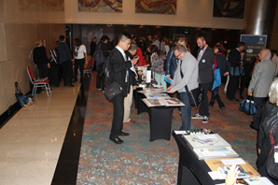 | 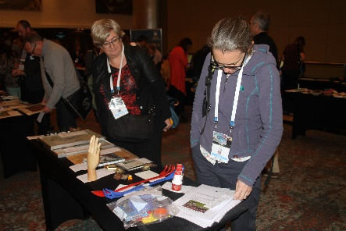 | 